TASK OF AWS and AZURE
1)Launch one ec2 using Amazon Linux 2 image and add script in user data to install
Apache.
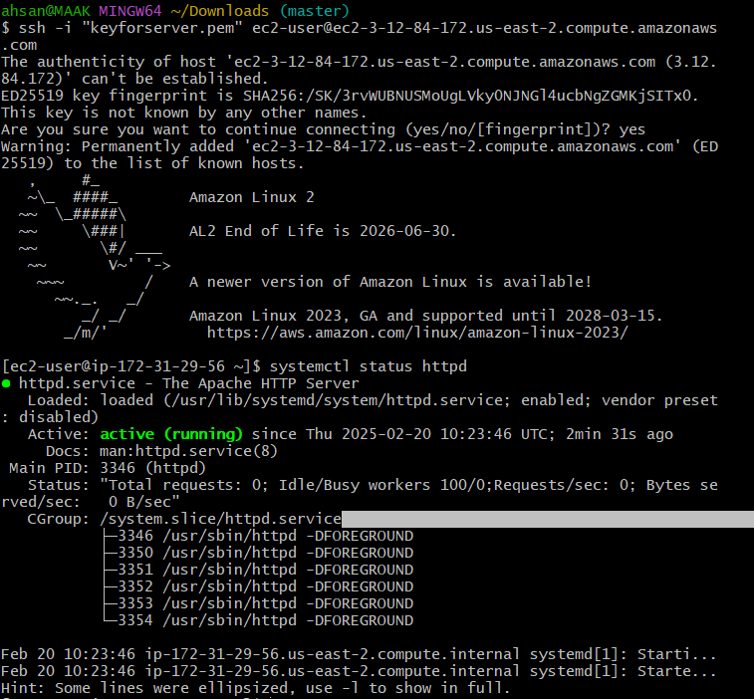

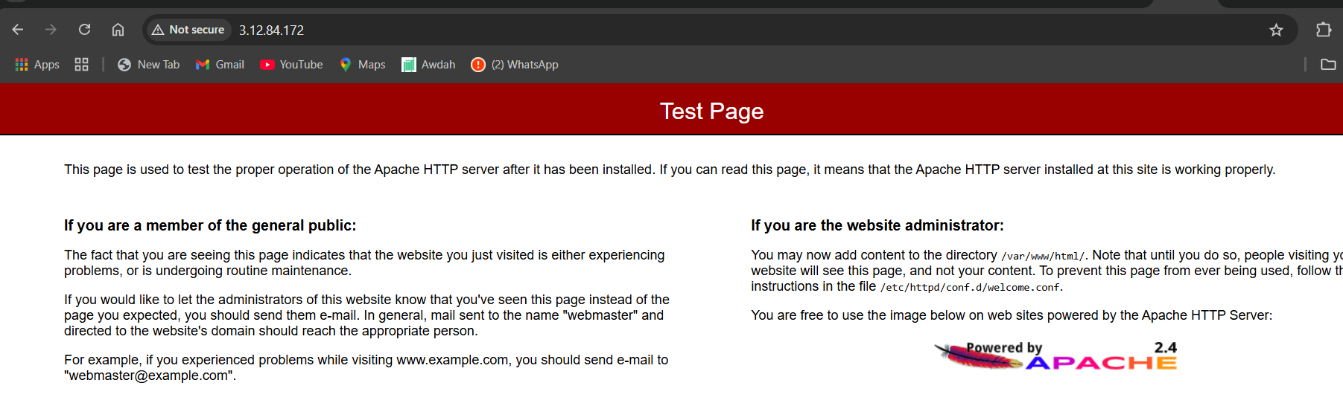
2) Launch one ec2 using Ubuntu image and add script in user data to install Nginx.
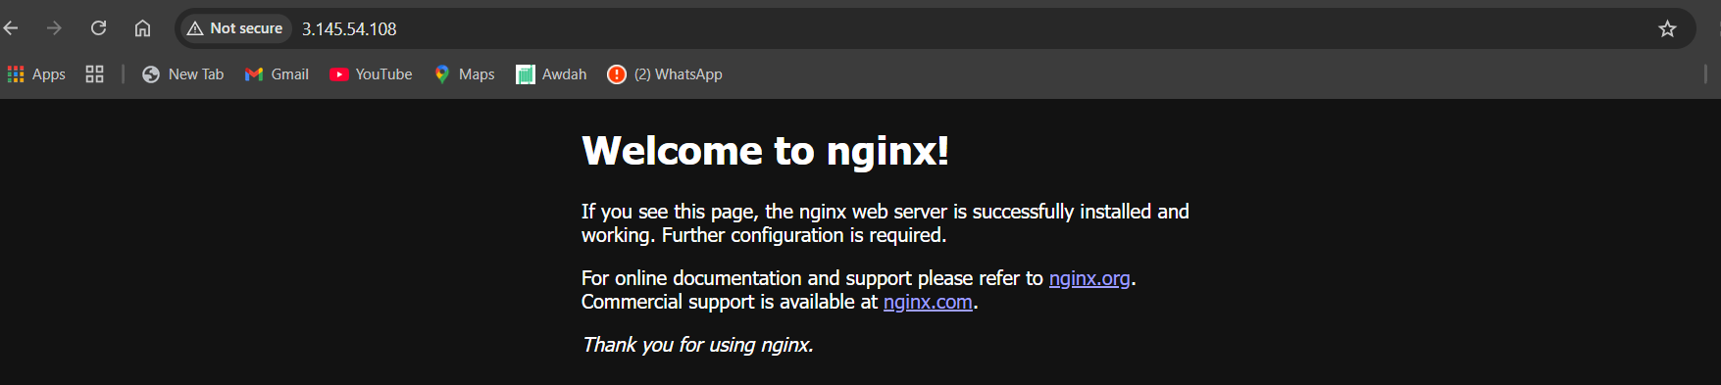
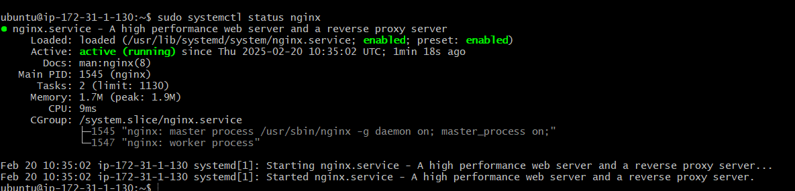

3) Launch one windows server and install tomcat in windows.

Install windows through and remotely connected

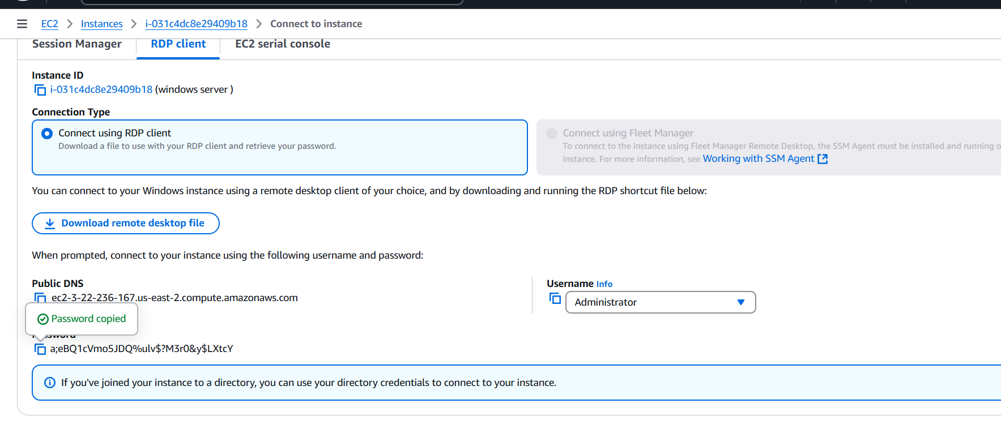
4) Take snapshot of the instane created in Task 1.
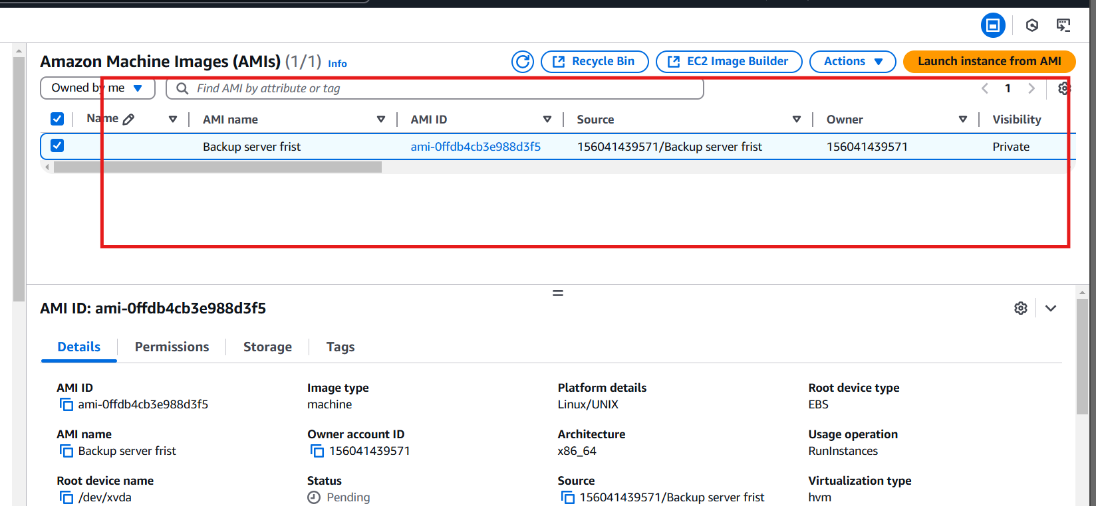

5) Assign password less authentication for ec2 created on Task 2.

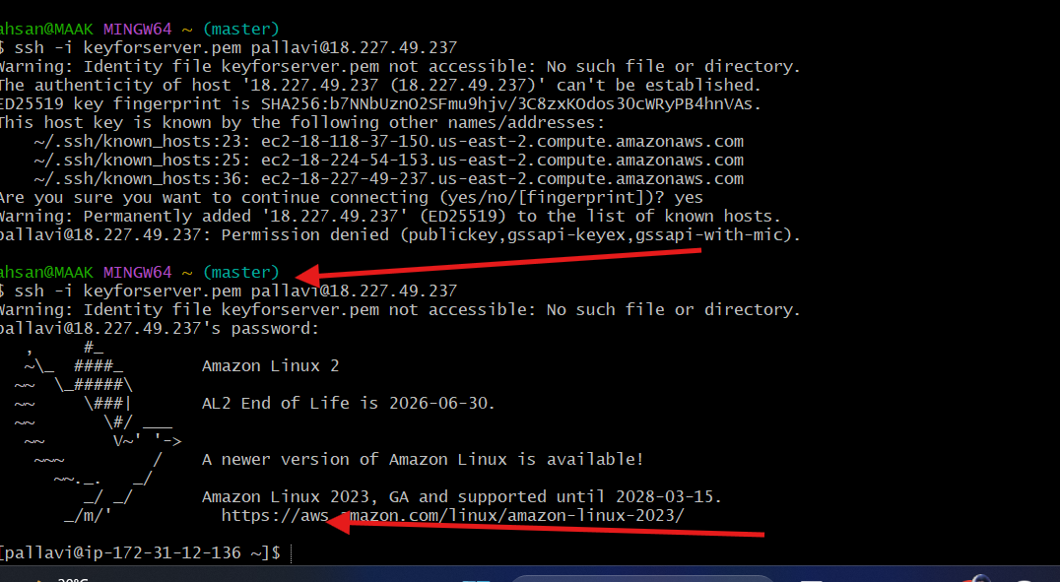

6) Launch any ec2 using spot purchasing optio

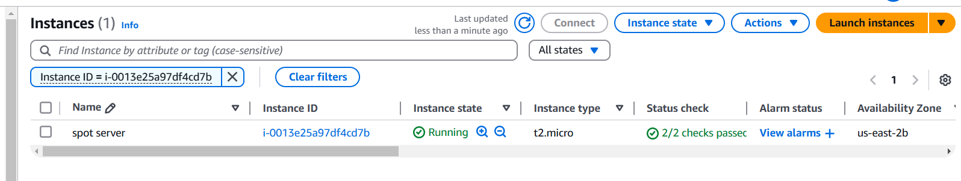

7) Enable Termination policy on ec2 created in Task 2.
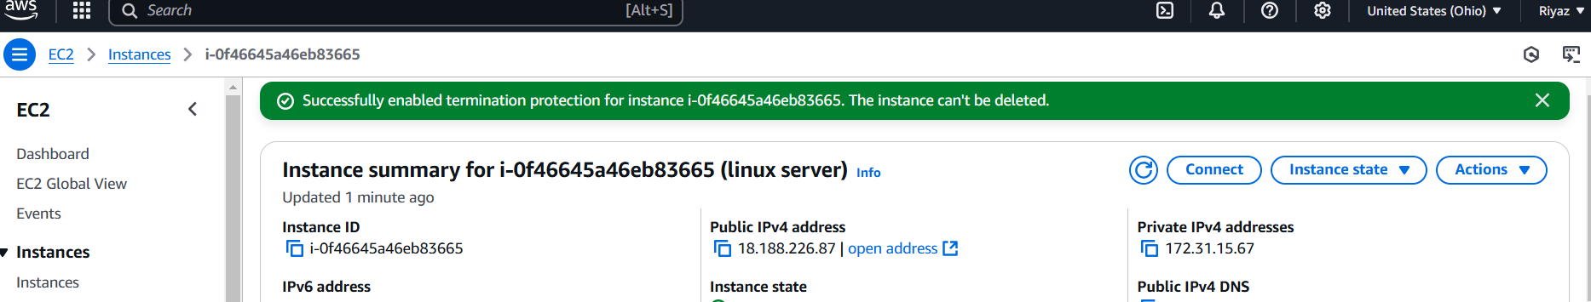

8) 8) Launch one ec2 using Aws CLI.

